# **Chemistry Geneaology:**

# **User Manual**

# Brief:

This document contains all instructions required for a User and/or Administrator of this application to navigate through the application and the various tasks that can be done with this application.

# Table Of Contents:

Section Page Number(s)

1. Prerequisites Page 3

2. Expected URL Page 3

3. Application Interface Basics

3.1. Basics of the Application Interface: Overview Page 4

3.2. Basics of the Application Interface: Overview Details Page 4, 5

3.3 Basics of the Application Interface: Constant Elements Page 6

4. Search

4.1. Basic Search Page 7

4.2 How to Search Page 7, 8

4.3 Search Visualization Page 9, 10

4.4 Search Detailed Information Page 11, 12

5. Detailed Information

5.1 Navigating to Detailed Information Page 13, 14

5.2 Detailed Information Page Layout Page 15, 16

5.3 Navigating to Other Detailed Info Pages Page 17

6. Log in Page 18, 19, 20

7. Log out Page 21

8. Submission *

8.1 Navigating to the Submission Page Page 22

8.2 Furnishing the Submission Page Page 23

8.3 Submitting the Information Put Into The System Page 24

8.4 Submitting Individual Elements Page 25, 26, 27

9. Edit *

9.1 Navigating to the Edit Page Page 28, 29

9.2 Making an edit to the page Page 30

9.3 Submitting the Edit Page Page 31

10. Admin Panel @

10.1 Navigating to the Admin Panel Page 32

10.2 Notifications Page 33

10.3 Approving Registered Users Page 34

10.4 Viewing current Administrator group Page 35

10.5 Viewing current User group Page 36

10.6 Accepting Newly Submitted Data Page 37, 38

11. Vocabulary Page 39

note:

Items marked with aN * beside them are logged in user only functions!

items marked with an @ beside them are administrator only functions!

# 1. Prerequisites:

Before running the application please ensure that you have the following:

1: A stable internet connection. This application is deployed online and has no downloadable component to itself, this application is completely web based.

2: An internet browser. We suggest that you use Google Chrome as this was the browser primarily used during development of this application, however other browsers should work equally well.

# 2. Expected URL:

The URL of the application is what is typed into the top of the browser in order to arrive at the webpage that hosts this application. This URL is decided by the Administrator of the application during the setup of this application, and will be decided at a later date by the Administrator.

Currently deployed URL, and an example of a URL in the Google Chrome web browser:



Figure 2.1: Image of the URL presented in the Google Chrome Browser.   
Please note the URL discussed in this section is boxed in the red color.

The currently deployed URL that may be used to access the current webpage is:

http://162.246.156.132:5000/search

For Administrators: If you desire to change this URL please refer to the Administrator Manual received with this software.

# 3. Basics of the application interface

# 3.1. Basics of the application interface: Overview

This application has multiple aspects to it’s User Interface. This section will briefly gloss over what can be seen from the main page of the application, for further details on functionalities please refer to their respective sections in this User Manual.

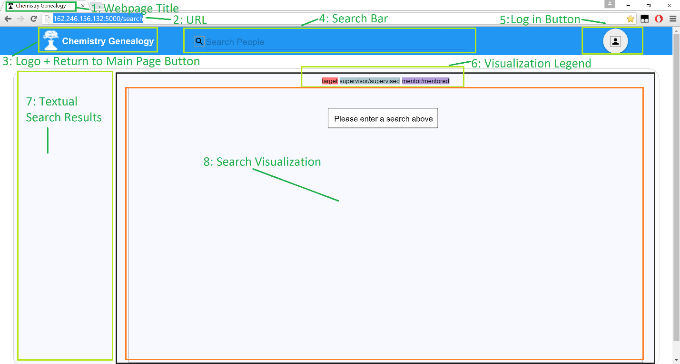

Figure 3.1: Image of the Main Page (URL/search) in the Google Chrome browser.   
Critical Objects are boxed in green, visualization is boxed in orange for clarity to prevent overlap.

# 3.2. Basics of the application interface: overview details

In this section I will refer to figure 3.1 above, if there is any confusion please refer to that figure. I will list off the descriptions in numerical order as they appear in that figure.

1. Webpage Title:

The Webpage title is shown in URLs at the top of the page in the tab. This is commonly used to identify the webpage someone is on. For this application the current Webpage title is Chemistry Geneaology with a flask icon—the same icon shown on the 3rd element of figure 3.1.

2. URL:

The URL is typed into the browser in order to access the webpage, please refer to section 2 in this User Manual for more Information.

3. Logo + Return To Main Page Button:

For this application to be easy to navigate, we provided a simple button to access the main page of the application. This also was combined with the logo to provide a consistent style and point of reference for users. Clicking this icon directs the user to the main page.

4. Search Bar:

One of the core functionalities of this application is being able to search the database to discover information. The search bar on this main page yields this functionality to this application’s users. Entering text into this field will search the database of the application for results that match the text input.

5. Log in Button:

This application has three sets of users:

1. Administrators: Users with elevated privileges as defined in the scope of this application.

2. Regular Users: Users with common privileges such as editing and submitting data.

3: Non-Registered Users: Users who are not logged in or have not registered an account.

This log in button therefore has the core functionality of placing the user who has arrived at this application’s webpage into one of the three categories located above. Someone who is logged in will have more privileges and be able to access more application functionality than someone who is logged in. Likewise, an administrator follows a similar log in pattern, yet because of their administrator status they have access to even more powerful functions in this application.

6. Visualization Legend:

This application comes bundled with powerful visualizations, the visualization legend indicates to the user what exactly is being represented below in the visualization. This allows users to quickly reference the critical data needed to decipher what is presented in front of them.

7. Textual Search Results:

As described in the 4th element of this figure (figure 3.1), search is a core part of this application. However searching must provide results that the user may interact with. The textual search results will be provided on this page in the section indicated on figure 3.1. Elements here may be interacted with in order to view details and navigate throughout the application’s various features. These features and functionalities will be described in later sections of this User Manual.

8. Search Visualization:

The 6th element of this figure (figure 3.1) described a Visualization Legend. This 8th element is the visualization itself. This application will, in this space, show to the user a visualization of the search data obtained from the database. Note: Currently for the 8th element there is a “Please enter a Search Above” box, this is temporary and prompts the users of this application to enter a search into the Search Bar to begin the visualizations.

# 3.3. Basics of the application interface: Constant elements

This application is very large, and can perhaps be daunting to a new user. Therefore maintaining a significant static element throughout every page of the application can dramatically increase User productivity and familiarlality with the application.

In our application the primary constant element that all Users will see throughout their use of the application is the header bar as depicted below.



Figure 3.2: Image of the Application Header Bar in the Google Chrome browser.   
The header bar is outlined in yellow.

This header bar includes the following elements:

1: Logo + Return to Main Page Button

2: Search Bar

3: Log in button / Log out button

For a briefing on the elements in the Header bar please refer to section 3.2. For details please refer to the table of contents for their respective sections.

# 4. Search

# 4.1. Search: Basic Search

Searching is the technique by which Users of this application can retrieve the data that they desire from this application. It is a core function in which a User may enter in the name of an individual and then retrieve information about him/her.

The Search Bar located in the header of this application facilitates this core function.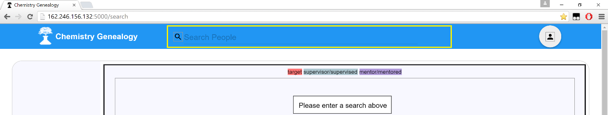

Figure 4.1: Image of the Search Bar in the Google Chrome browser.   
The Search bar is outlined in yellow.

# 4.2. Search: How to search

This application’s search engine uses the name of the individual within the application database as the core element to search the data. Therefore to obtain the search results of an individual, please enter **their name** into the search bar as depicted below.

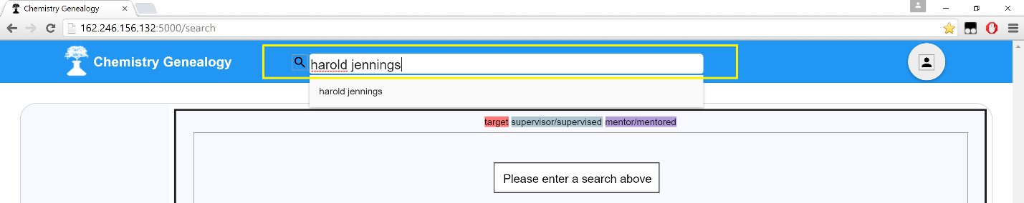

Figure 4.2: Search Bar being filled with an example name in Google Chrome browser.   
The Search bar is outlined in yellow.

Once this bar has a name input within itself this search bar will prompt a search within the database of our application. This will yield the results in boxes below the search bar as depicted below:

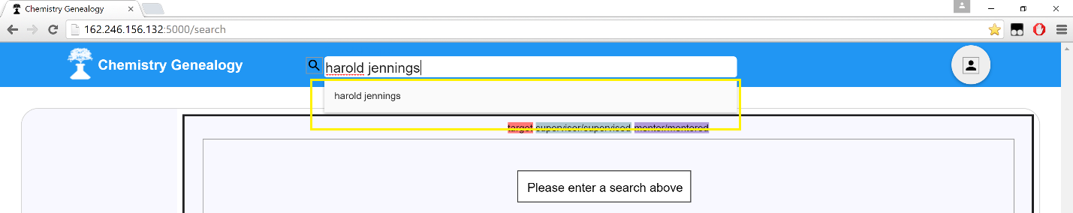

Figure 4.3: Search Bar being filled with an example name in Google Chrome browser.   
The Search bar results popup is outlined in yellow.

In other words, the search bar will return the results of the search, all possible matching results, in this popup box directly below the search bar.

This search bar also supports multiple results, as depicted below.

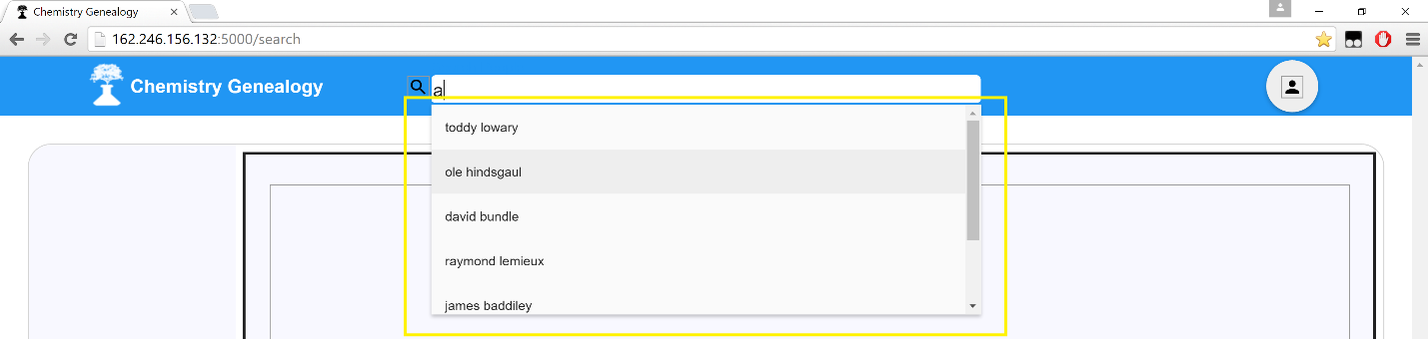

Figure 4.4: Search Bar being filled with an example letter (“a”) in the Google Chrome browser.   
The Search bar results popup is outlined in yellow. Note the multiple results with a scroll bar.

Now in order to use this search bar please click on the particular individual’s name who’s search information you are most interested in. How to do that is to hover over one of the elements, that will turn grey, and then to right mouse click this particular element.

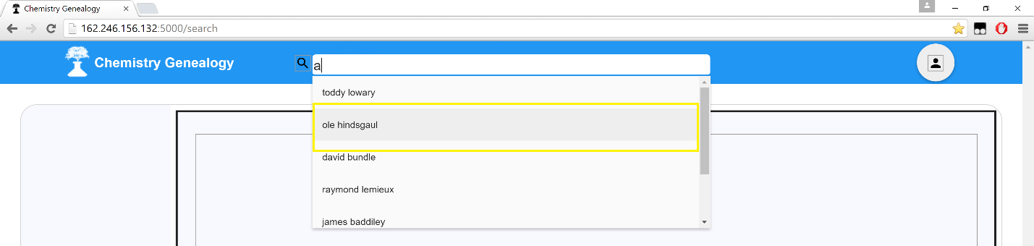

Figure 4.5: Search Bar being filled with an example letter (“a”) in the Google Chrome browser.   
The Search bar has many results. This is selecting a single search result highlighted in yellow.

This will trigger the page to undergo a series of changes I will describe in the sections immediately below.

# 4.3. Search: Search visualization

One of the core features of this application is that there is a fantastic visualization to accompany each and every search query performed by a user.

Depicted below is the webpage before a search is conducted. The yellow box encompasses the search visualization region of this page, where the visualization will be shown to the users of this application.

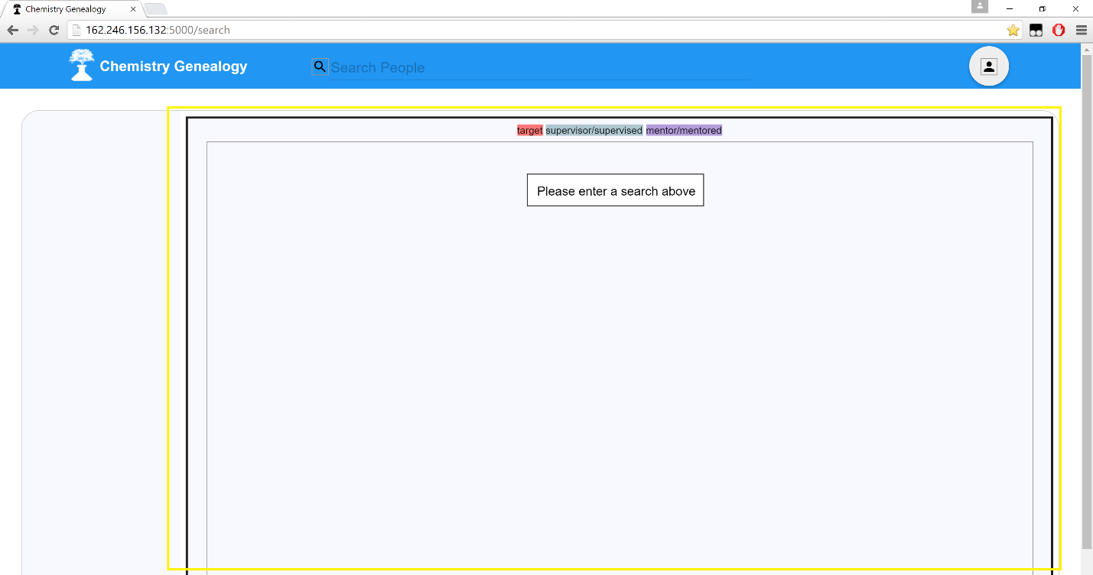

Figure 4.6: Search Visualization location on the main page.  
The location where the Search Visualization will be shown is highlighted in yellow.  
Currently this is not showing a visualization, instead prompting a user for search input.

When a search is put into the search bar, and a result is selected as described earlier in this section, the visualization region will be filled with a visualization as shown below.

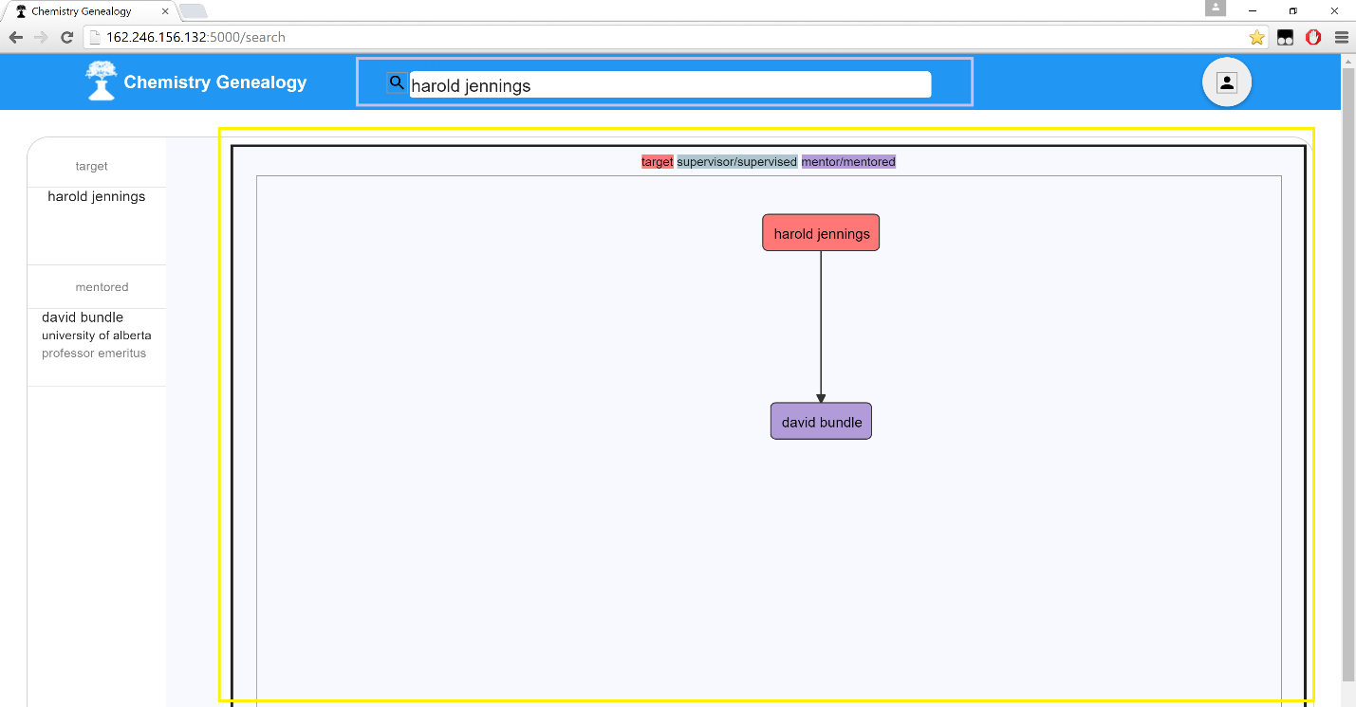

Figure 4.7: Search Visualization location on the main page.  
The location where the Search Visualization will be shown is highlighted in yellow.  
This image depicts a visualization for the search “Harold Jennings”.

As shown in figure 4.7, the search visualization is displayed in the region specified. And It yields the following information, as one follows the Search Visualization Legend directly above the search visualization:

1. Harold Jennings is the target of the User’s search.  
 2. David Bundle was found in the database to be an individual that Harold Jennings Mentored.

The Search Visualization Legend is shown in detail below, for any questions about vocabulary and definitions of the terms in the scope of this application please refer to the Vocabulary section within this User Manual. The purpose of this element is to ensure that users of this application can always interpret that Visualization data.

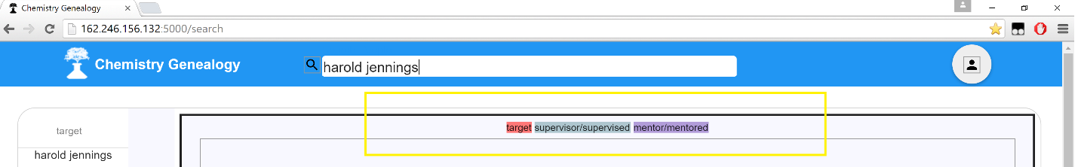

Figure 4.8: Search Visualization Legend location on the main page.  
The location where the Search Visualization Legend will be shown is highlighted in yellow.  
This image depicts a visualization for the search “Harold Jennings”.

# 4.4. Search: Search detailed information

In this application Searching must be accompanied with more detailed results about the search’s target. This is provided on the left side of the visualization as a core accompaniment to the visual representation of the data.

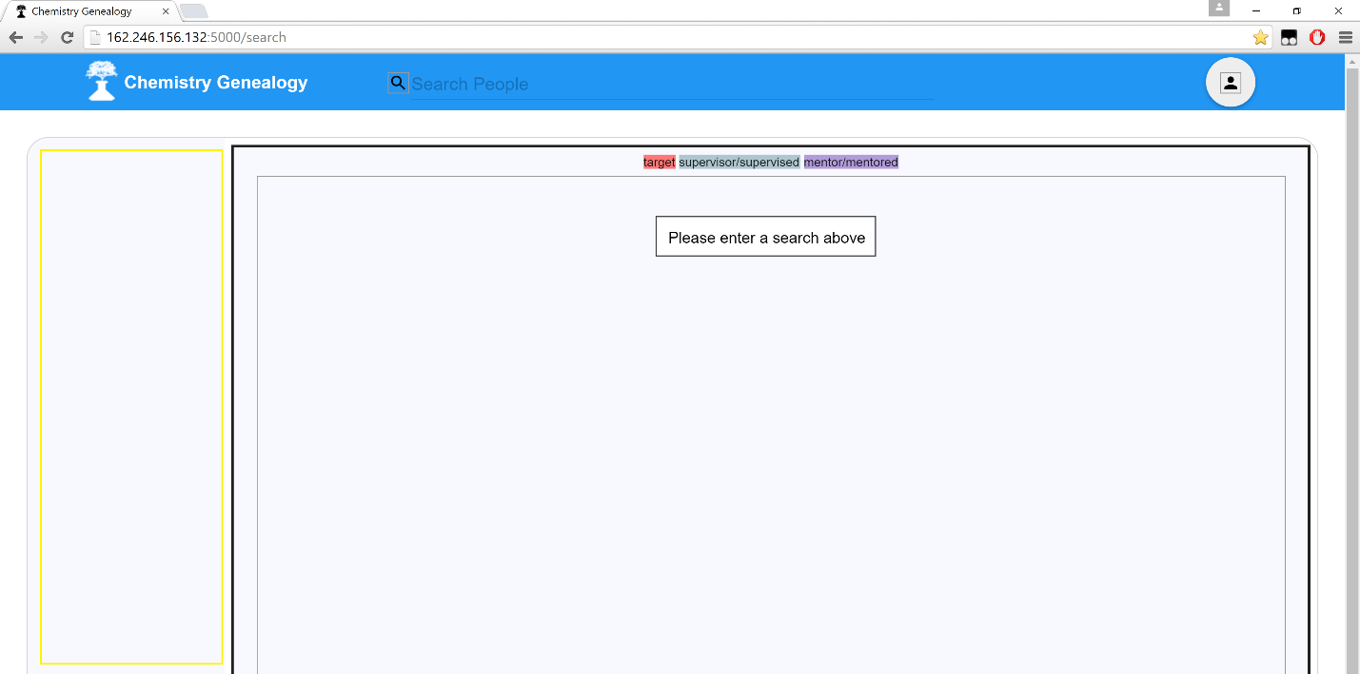

Figure 4.9: Search Detailed Textual Information  
The location where the Search Detailed Textual Information will be shown is highlighted in yellow.  
Currently there is no search therefore the results are empty.

Now upon entering a search, as described in earlier parts of this section, this region will be populated with data to match the search target as shown below.

There are four major sections in this that correspond to the following:

1: “Target”: This is the individual who you searched for in the search bar.

2: “Mentors”: These are the individuals who mentored the searched individual in a postdoc.

3: “Mentored”: These are individuals who the searched for individual mentored in the past.

4: “Supervisors”: These are the individuals who supervised the searched for individual in their degrees.

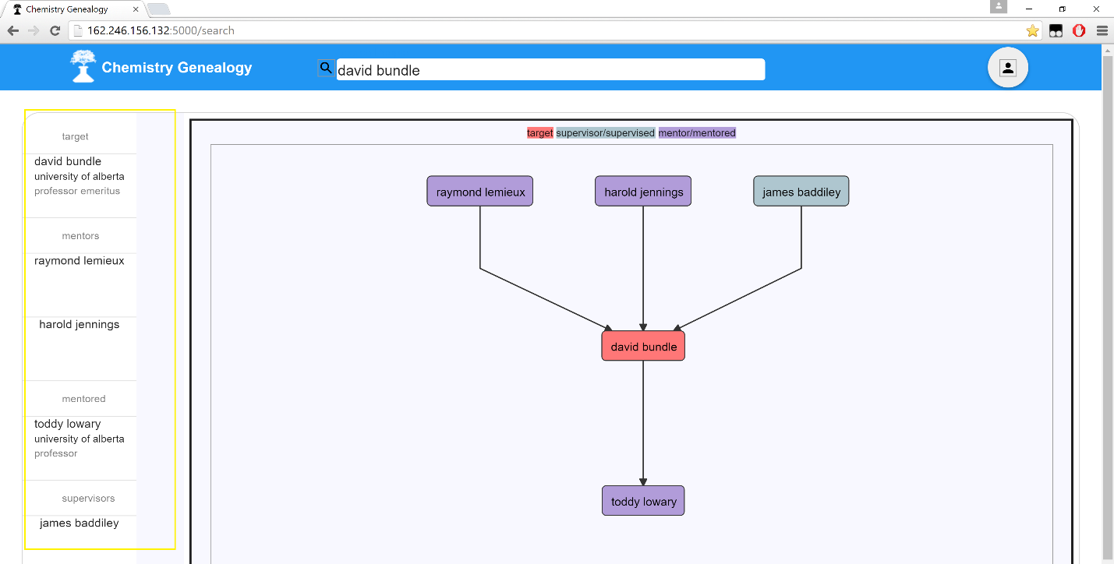

Figure 4.10: Search Detailed Textual Information  
The location where the Search Detailed Textual Information will be shown is highlighted in yellow.  
This image represents the searched data.

Critical notes:

1: Multiple results will be shown under the same column, in figure 4.10 this is shown under Mentors.

2: If there are no results the entire header will be absent, indicating there are no results for that header.

# 5. detailed information

Detailed information in this application is used when the basic search results displayed in the main page do not provide enough information for the application user.

# 5.1. navigating to detailed information

Before you begin: Navigation to the detailed information of this application hinges on the fact that the user initially search for someone. Therefore, if you are not aware of how to search, please review section 4 on searching in this application.

First of all begin a search, and select a target as displayed below you will furnish the main page with the search result data.



Figure 5.1: Navigation to Detailed Information Part 1  
The location where the Search Detailed Textual Information will be shown is highlighted in yellow.  
This is critical as to navigate to view the detailed information of a user is done on this panel.

Now that you have the detailed textual representation of the search data on the side bar, as highlighted in yellow in figure 5.1, a user can click on any of the names to view details on that particular user!

In this example I will choose to view the details on the Target of the search. Therefore I will click David Bundle under the Target header within the Search Detailed Textual Information section depicted above in figure 5.1.

The User will then be directed to a page representing the detailed information for the particular individual who they just clicked on. The page looks like the one below in figure 5.2.

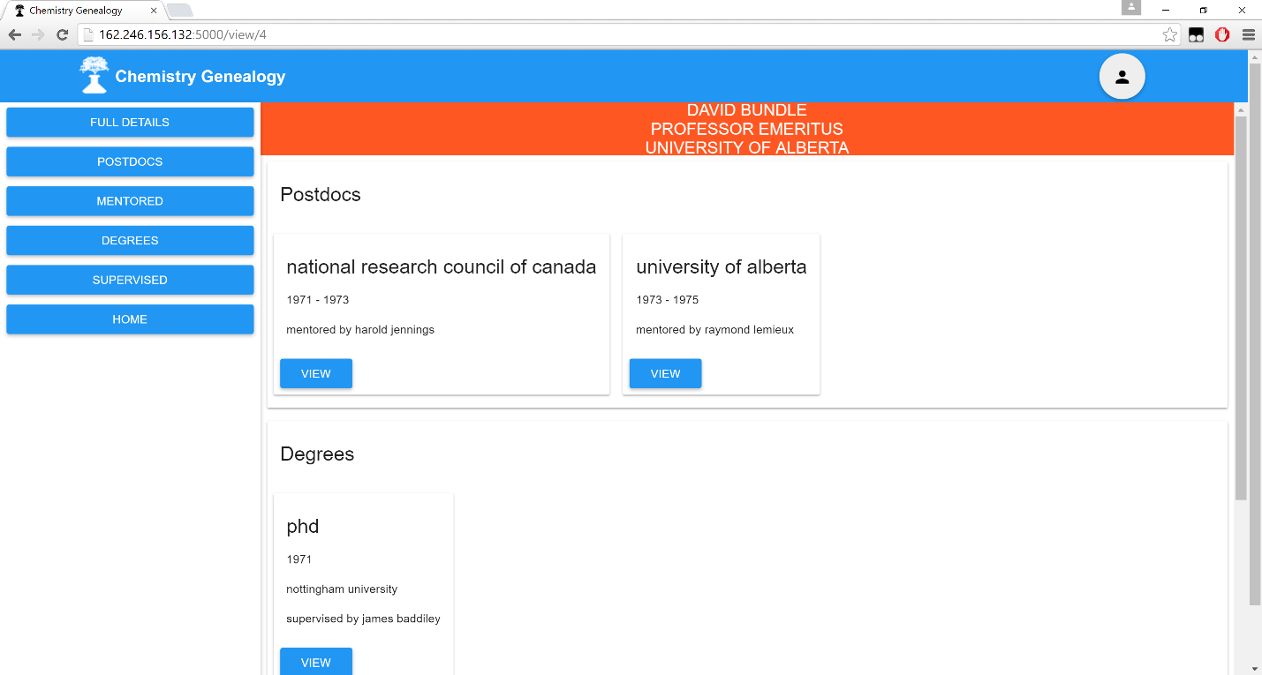

Figure 5.2: Navigation to Detailed Information Part 2  
This page is the page that the users should arrive at to view detailed information on this individual.

# 5.2. detailed information page layout

This figure, figure 5.3, depicts the Detailed Information page.

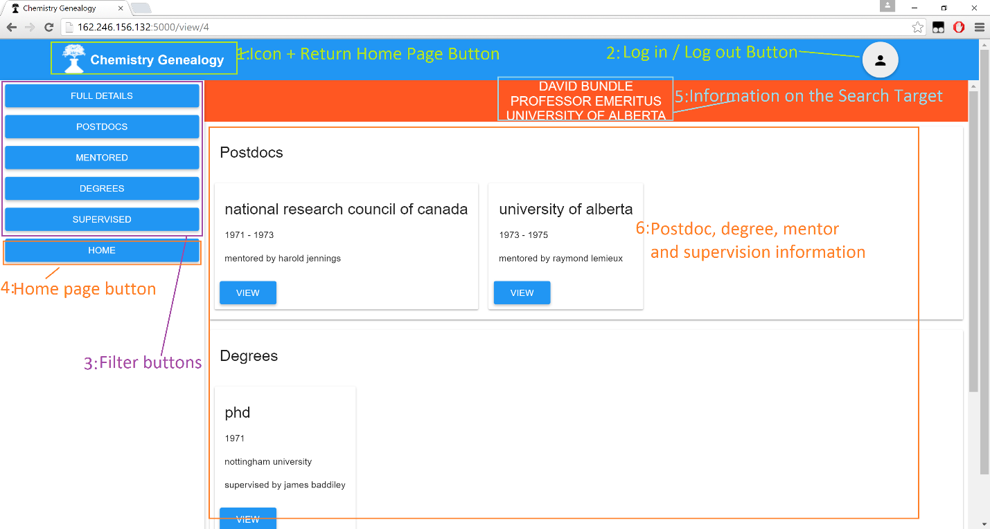

Figure 5.3: Detailed Information Page Layout.

1. Icon + Return Home Page Button:

This element is the exact same as was described in the page overview in section 3.

2. Log in / Log out button:

This element is the exact same as was described in the page overview in section 3.

3. Filter Buttons:

This page has at most 4 sets of data, these 4 sets are represented in the filter buttons. Each button can be used in order to reduce the amount of information on the page—this can be extremely useful for pages with a daunting amount of information located on themselves.

4. Home Page Button:

This home page button provides a quick and easy access button to navigate to the home page of this application directly below the filter buttons.

5. Information on the Search Target:

The view page is viewing a particular individual’s information on their degrees, postdoctoral appointments, etc. These top three pieces of information are the:

1. Name

2. Current Position

3. Current Institution

For the particular individual.

6. Postdoc, degree, mentor and supervision Information:

This section is the core information of the page, within this section will be a maximum of four partitions of the data on this individual. If the section naming is not clear please go to the vocabulary section of this User Manual.

critical notes:

1. If there are multiple instances of any of the four partitions, they will be added horizontally like so.

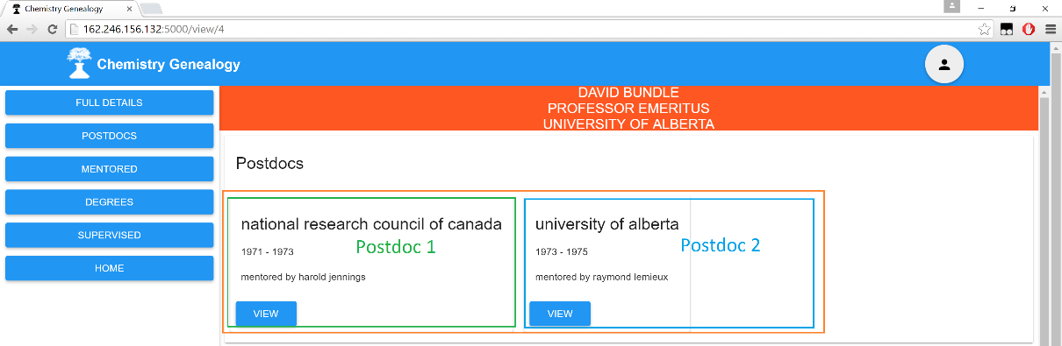

Figure 5.4: Detailed Information Horizontal Expansion for Multiple Entries.

2. If there are no instances of a particular partition then the partition will have no information inside of itself whatsoever.

# 5.3. Navigating to other detailed info pages

For this application there is no doubt a lot of relationships between individuals, and we want to emphasize these relations. Therefore, we added a feature where you can, on a particular individual’s page, navigate to the pages of those who are related to them. In other words, if you see on a detailed information page that X mentored Y, and you are on X’s page, you can quickly navigate to the detailed information page of Y!

On the Detailed Information page there are a variety of people that the individual has some relation with, in order to navigate to their detailed information page all a user needs to do is to click on the view button associated with that particular relation.

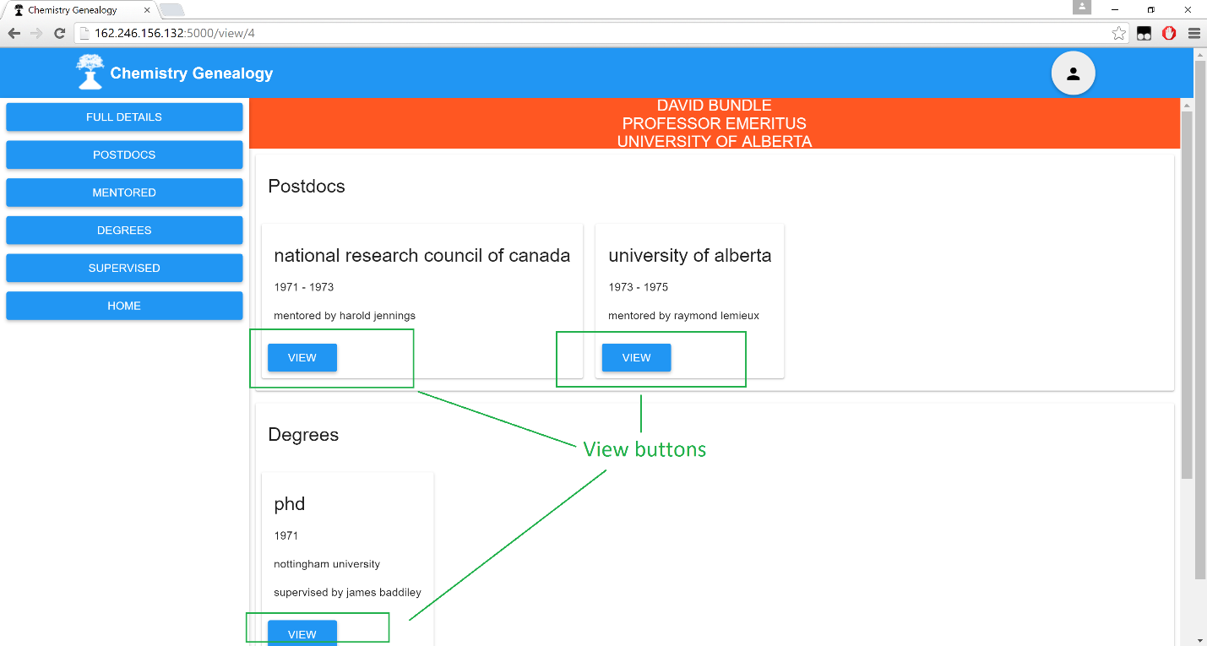

Figure 5.5: Navigation to relation pages of the Detailed Information Page.  
Click the View Buttons to navigate to that related individual’s View Detail Page.

# 6. Log in

Our application has a host of different user groups, and therefore the login procedure will differentiate between particular users of the application. Particular user groups come with particular powers within the system as will be outlined in a section detailing user privileges, please go there for details on that.

Located within the header of the application, consistent throughout the entire application, is the log in button.



Figure 6.1: The log in button.  
Clicking this button brings up the log in screen.

This general log in button is used for both registered users as well as administrators of this application. User and Administrator privileges are distributed throughout their account’s abilities in the application seamlessly. If a user is not meant to access something then it is simply hidden from them and they will not be aware of it.

Clicking this log in button brings up a login screen to the user as shown below in figure 6.2, the rest of the application is greyed out until the login process is completed.

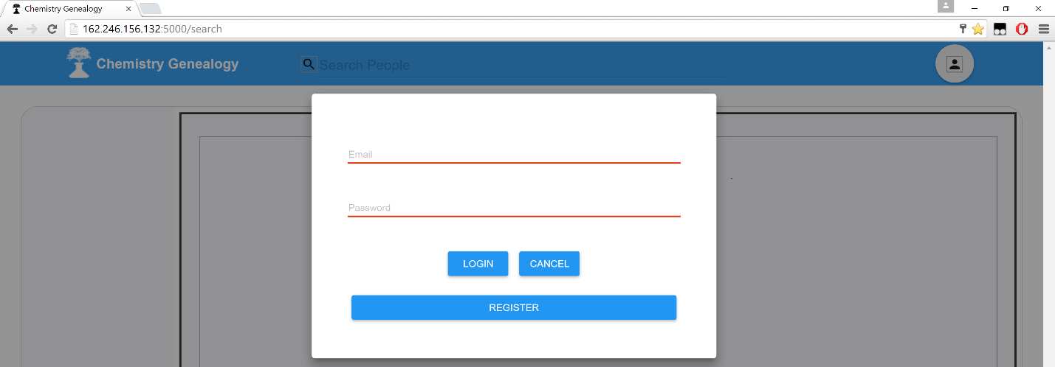

Figure 6.2: The log in screen.  
This is the core screen that the user can use to log into the application.

To remove this screen, the user can either click outside of the box (in the greyed regions of the application) or hit the cancel button. Either will remove this screen from the user’s view.

If the user already has an account, then they should use the e-mail and the associated password that they registered with to log into the system.

One feature with Google Chrome and our application is that autofill exists.

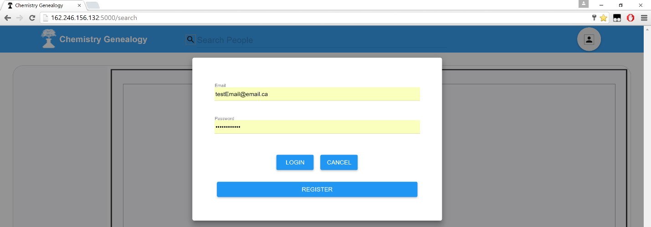

Figure 6.3: Autofill of Login Credentials.  
Note: This works in Google Chrome at the very least.

To log into the application from this point all the user has to do is hit the login button.

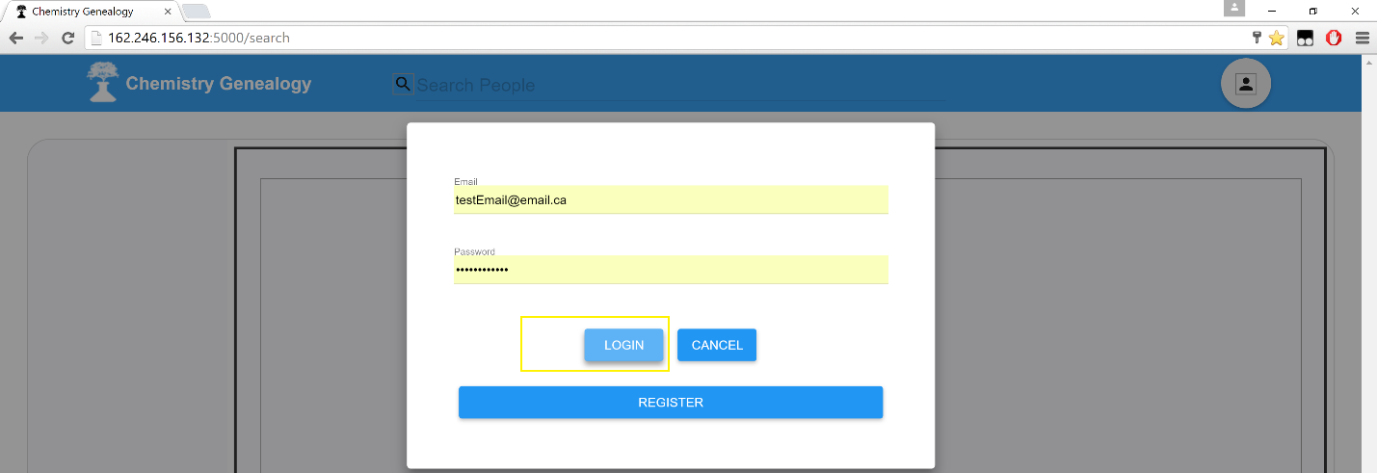

Figure 6.4: Hitting the Login Button on the Login Screen.

Now for this example we logged in with an administrator account. Normal users won’t see all of this, as I will explain below.

However, do note the changes in the header of the webpage.



Figure 6.5: The header details **after** logging into the application.

1. Admin Panel:

This is a button that **only administrators** can view, regular users will never be able to view this button. Clicking this button allows an administrator to navigate to their administrator panel, which is described in detail in another section of this User Manual.

2. Submit Button:

This is a button that **only Accepted Users and Administrators** can see and use. This allows the submission of a new individual into the database of the application. The submission process will be detailed in a subsequent section of this User Manual.

3. Logged In User + Log Out Button:

This is the Log OUT button for the application. But furthermore it shows the name of the account that the application user is currently logged in with. This can be helpful to users who are not sure which account they logged in with!   
  
Logging out will be described in the next section.

# 7. Log out

In an application where users can log in to gain special functionalities in the application, giving users the ability to log out is rather fundamental.

If you are not sure how to log in, please refer to the previous section on logging into the application. This section starts off from the screen where the user is already logged in.

Starting from the logged in state, note the button in the top right hand corner of the header (constant through all pages of the application) that states the currently logged in user’s email.



Figure 7.1: Currently Logged in state.  
Note the currently logged in user button highlighted in yellow, this is the log out button.

Clicking the button highlighted in figure 7.1 will bring up a log out prompt to the user as follows in figure 7.2.



Figure 7.2: Pressing the Log Out Button.  
Note the LOGOUT popup that appears, this must be pressed to log out of the application.

Pressing this LOGOUT button that popped up from the application will log the user out of the system.

This can be confirmed by seeing the header returned to it’s original state before logging into the system!



Figure 7.3: Logged out state of the system.  
Note that the header has returned to it’s prior state!

# 8. Submission

Submission in this application is the process by which Registered Users of the application can submit new information into the system on individuals.

**All submissions** **must first be approved by the administrator* before they can be seen.**

*For details on administrator approval, please read a subsequent section of this User Manual.

# 8.1. Navigating to the submission page

Navigating to the Submission Page requires that a user be logged in on their account within this system. Users who are not logged in do **not** get to submit data to the system.

This therefore requires that a user knows how to log in, if they do not they should consult section 6 of this User Manual.

From the logged in state, click the submit button as depicted below in figure 8.1.



Figure 8.1: Logged in state of the system.   
Where the submit button is located.

Now the user will be on the submission page for the application, shown in figure 8.1 below.

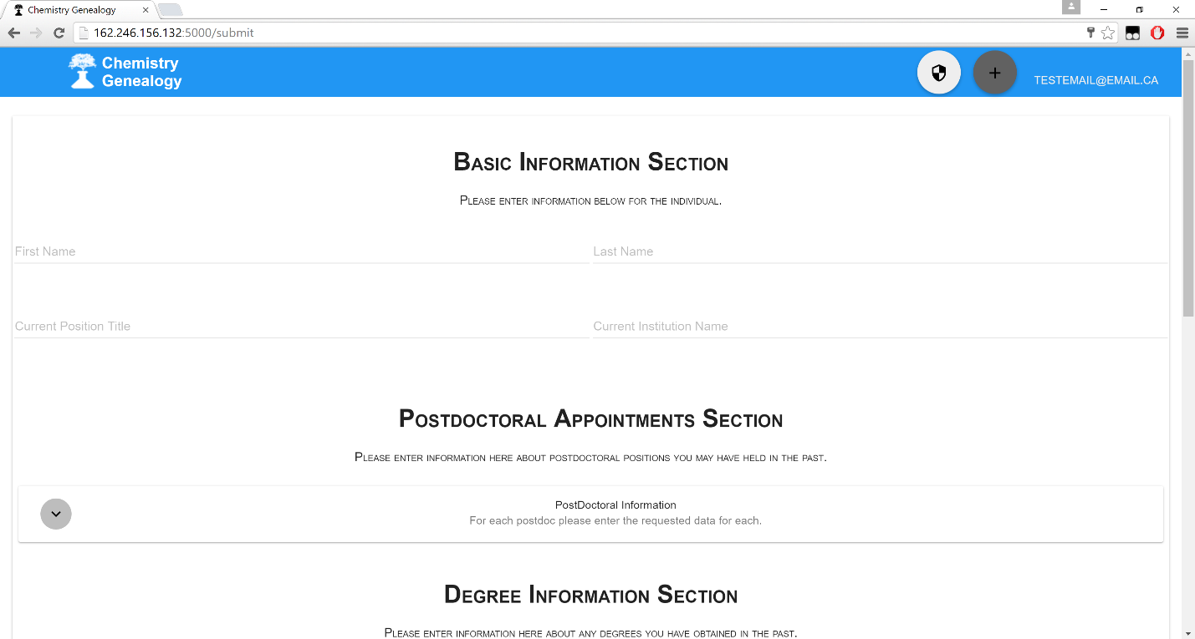

Figure 8.2: Submission Page Navigation

# 8.2. furnishing the submission page

It is clear that on this webpage that there is a large volume of information to be filled out. I will now explain it.

1. Basic Information Section:

This section is going to be populated with 4 very simple fields that will define the individual that the submission is concerned about in particular.

2. Postdoctoral Appointments Section:

This section will contain within itself each of the postdoc appointments that the submitted individual has been involved with.

Note: This section can hold multiple postdocs within itself. Each with it’s own set of data. I will explain the individual postdoc submission process in the subsequent section.

3. Degree Information Section:

This section will contain within itself each of the degrees of the submitted individual.

Note: This section can hold multiple degrees within itself. Each with it’s own set of data. I will explain the individual degree submission process in the subsequent section.

4. Postdocs this Person Mentored Section:

This section will contain within itself each of the postdoc appointments the submitted individual has mentored.

Note: This section can hold multiple instances within itself. Each with it’s own set of data. I will explain the individual instance submission process in the subsequent section.

5. Degrees this Person Supervised Section:

This section will contain within itself each of the degrees the submitted individual has supervised.

Note: This section can hold multiple instances within itself. Each with it’s own set of data. I will explain the individual instance submission process in the subsequent section.

# 8.3. submitting the information put into the system

Once all of those sections above have been filled then a user may now navigate to the bottom of the page and hit the ultimate submission button on the bottom of the page as depicted below in figure 8.3.

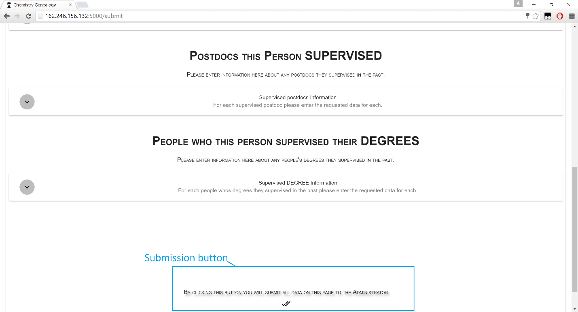

Figure 8.3: Submission Page Ultimate Submission Button.  
Note: This is at the very bottom of the page.

Now the data is submitted to the system and will be waiting in the administrator panel for administrator approval.

# 8.4. Submitting individual elements

For this page, one will note that there are multiple expandable and collapsible boxes. They all follow the same idea, and thus I will only explain one in this example. All others follow the same pattern of actions to submit their individual elements.

Here I will focus upon the section dedicated to the Postdoctoral Appointments Section

Below, in figure 8.4, is the section highlighted in blue with the button to expand the section highlighted in red.

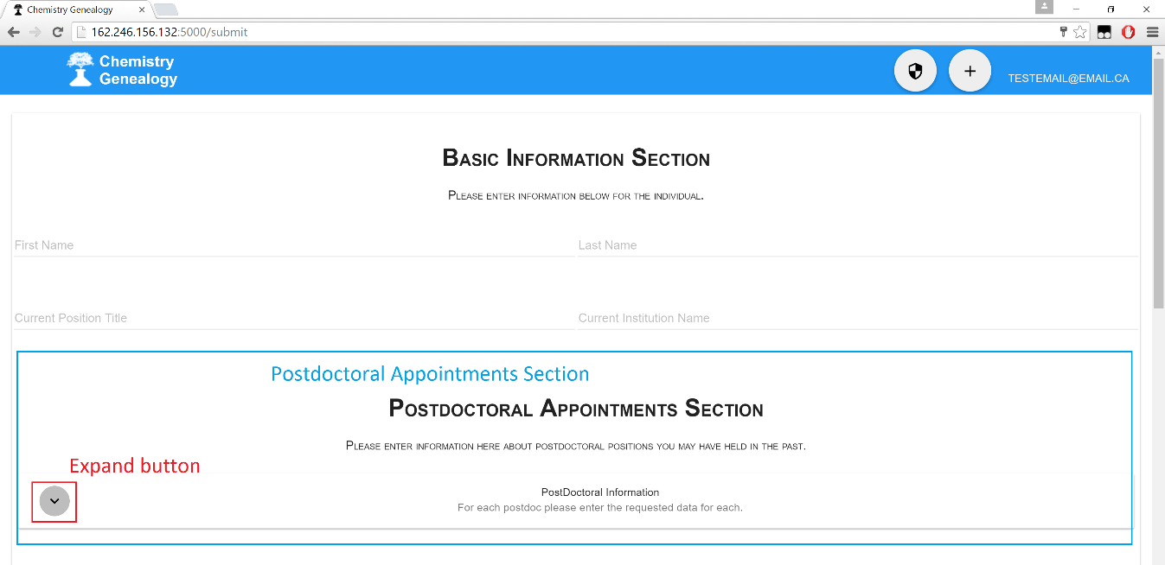

Figure 8.4: Submission Page Postdoctoral Appointments Section  
The entire section is highlighted in blue. The expand section button is highlighted in red.

Now with the section in front of yourself, you can now hit the expand button shown in figure 8.4 and this section will expand as depicted below. You are still located on the same page, just this section now expands from it’s collapsed version.

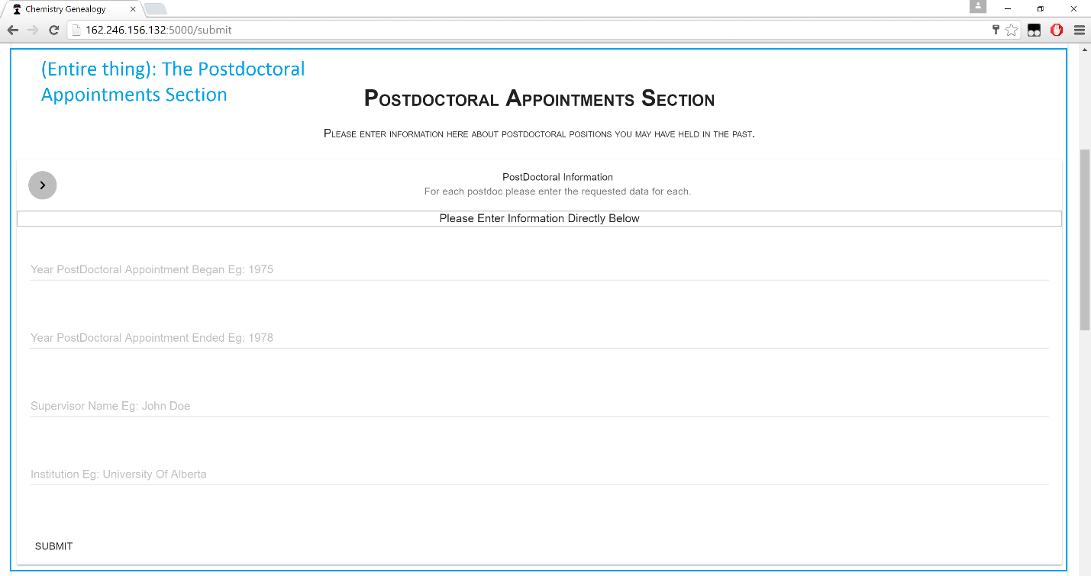

Figure 8.5: Submission Page Postdoctoral Appointments Section **Expanded**.  
The entire section is highlighted in blue.

Now in order to submit an individual Postdoctoral Appointment for this person who the Submit page is for, please fill in all of the pieces of data requested. **All data fields must be filled, none may be left empty.**Once all fields are filled, please hit the submit button at the very bottom of this form. This will take all of the fields from this section and combine the fields into an individual Postdoctoral Appointment for this individual.

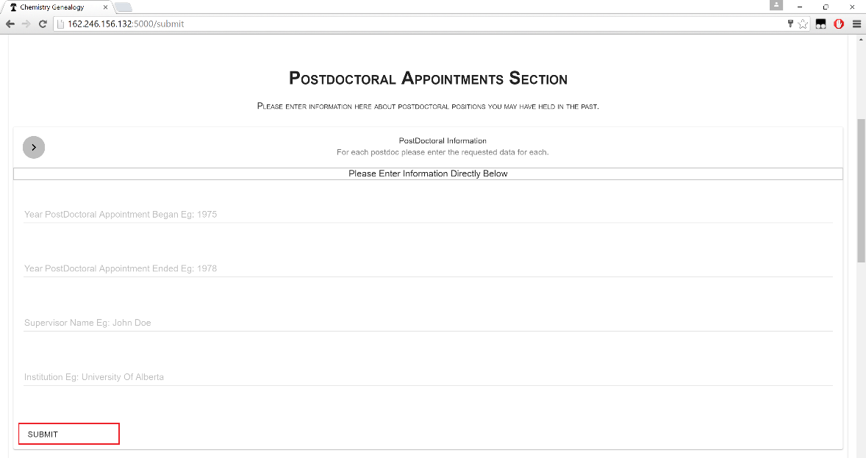

Figure 8.6: Submission Page Postdoctoral Appointments Section **Submit Button.**

Now below the form where you just filled out data you can now find a section dedicated towards displaying the submitted postdoctoral appointments.

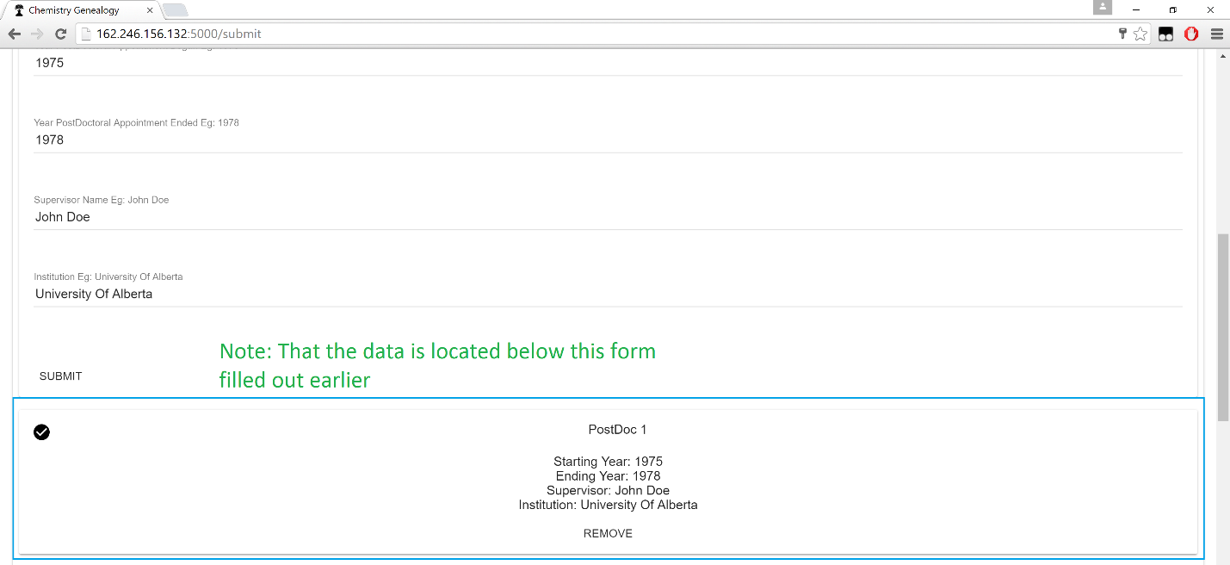

Figure 8.7: Submission Page Postdoctoral Appointments Section **after hitting submit.**

Note: When there is more than one submitted element for a particular section (In this instance more than one Postdoctoral Appointment submitted), the postdocs will be lined down vertically.

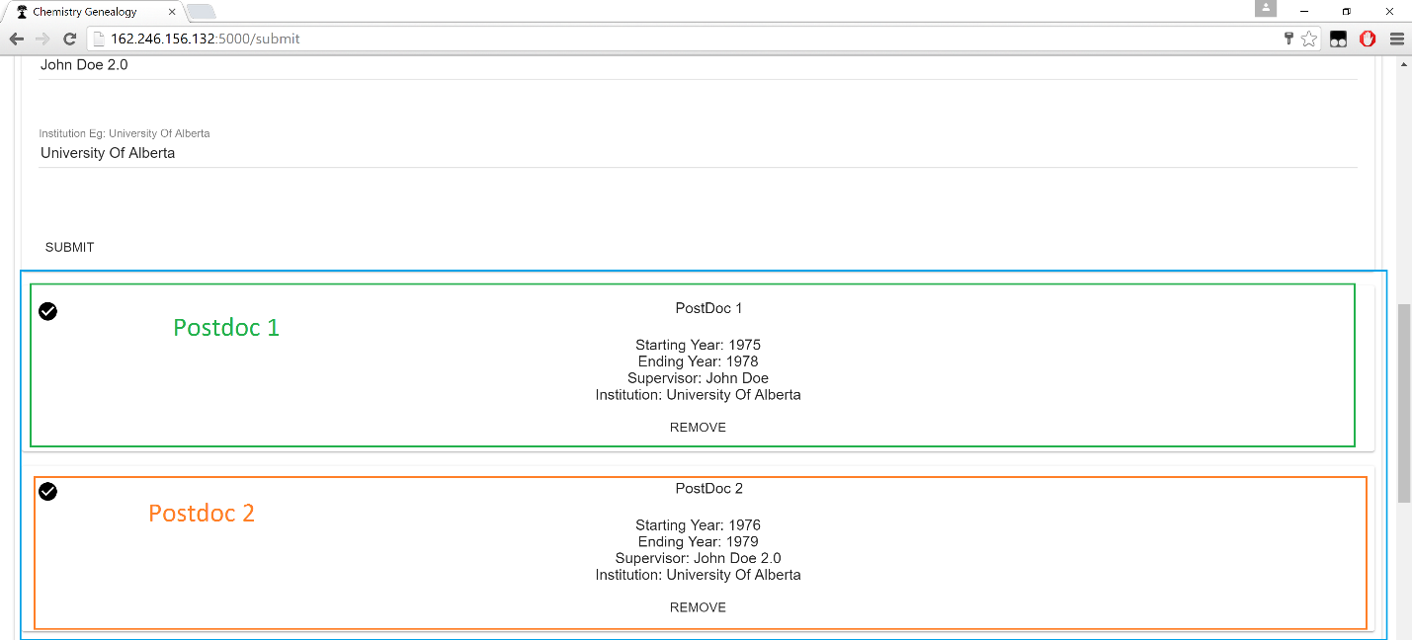

Figure 8.8: Submission Page Postdoctoral Appointments Section **after hitting submit on two postdocs.**

Note: When submitting multiple postdocs it is up to the user to manually clear the fields before entering a new postdoc to submit. **They do not automatically clear.**

Note 2: This does not submit the entire submission page to the application. Only this individual element.

Hit the remove button to remove an element.

# 9. edit

In this application we have a large volume of data, editing the data contained within the application therefore is critical to proper functioning of the application over time. Navigating to the Edit Page requires that a user be logged in on their account within this system. Users who are not logged in do **not** get to submit data to the system.

Here I am **making the assumption that I may pick off from the log in screen**, to review how to log into the application please read over section 5 in this User Manual.

Furthermore, **you must know how to navigate to view the detailed information** pages of individuals within this application. If you do not know how please review that section in this User Manual.

# 9.1. navigating to the edit page

The edit page is going to not be a single individual page. This page is going to be associated with a particular individual who already has their data residing within the application.

First, follow the steps to navigate to the view page of the individual, who’s information you desire to edit.

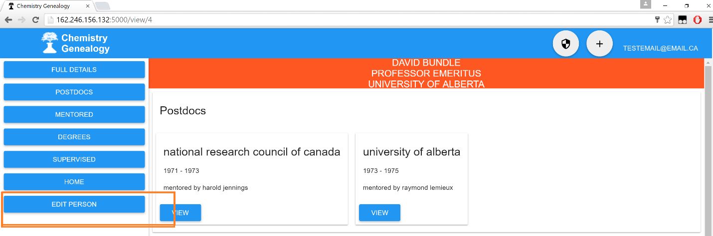

Figure 9.1: View Detail Page when logged into the System.  
Note the Edit Person Button highlighted in orange.

Note the button highlighted in Orange in figure 9.1, this button is available **only to logged in users.**

This button when pressed will take the user to the edit page for the individual who’s view page they were on.

Once the button is pressed the user will be taken to the edit page for that person.

Note 1: This page follows the exact same principles and ideas of the submit page (Section 8 in this User Manual.)

Note 2: This page is already furnished with data.

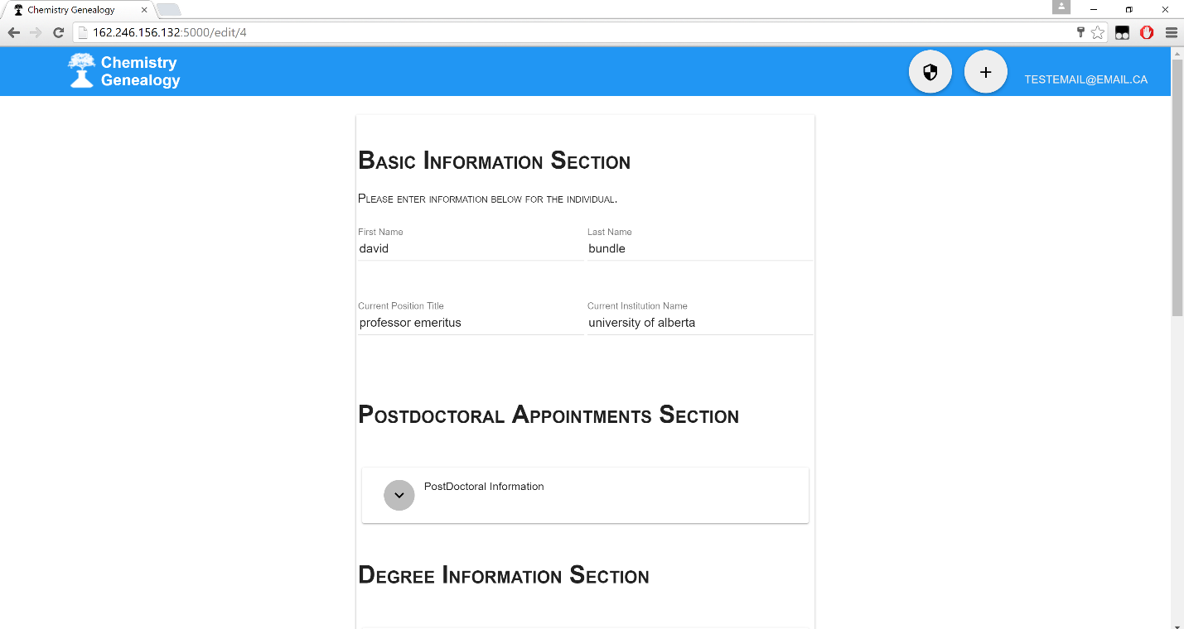

Figure 9.2: Edit page.  
Note the fields already have values in them, these are the values already in the system  
for this individual.

Now the parallels of the submit page (Section 8 in this User Manual) should be readily apparent. The same expanding/collapsing boxes, with the same fields. The sections are also the same.

To find out more detail on this edit page’s layout and details I will actually send you to read Section 8 on the Submit page in this User Manual—where it is already very well explained.

# 9.2. Making an edit to the page

Once the edit page is loaded up you already have all of the fields available to you just like on the submit page. To make an edit, go to a field which already will have a value in it, and change that field to the value that you want to see there.

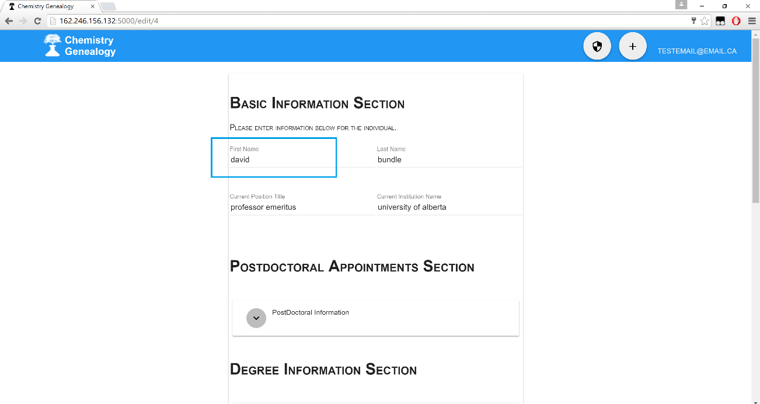

Figure 9.3: Edit page First Name field with a value in it.

Now change the value to something else.

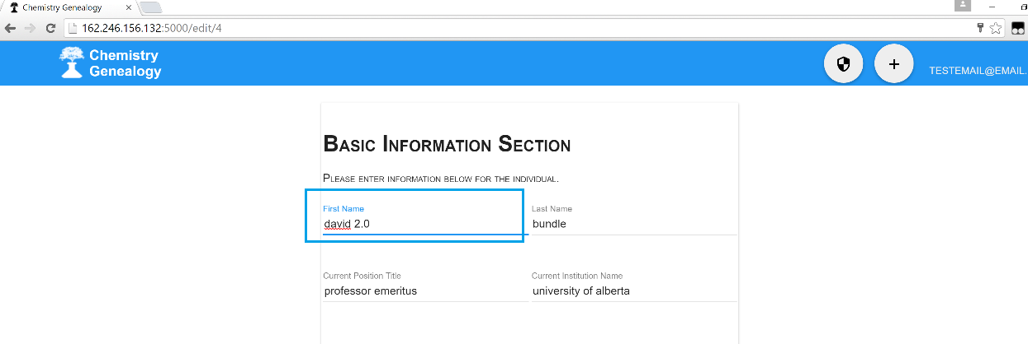

Figure 9.4: Edit done to the First Name field on the Edit Page.

The value within the edit page is changed.

**However note that this has not submitted the change to the application. The change will not be there by merely doing this step. It must be submitted, which is the next section (9.3).**

# 9.3. submitting the edit page

Once the desired edits are made to the edit page, a user **must** scroll down to the bottom of the page and then hit the final submission button for the entire edit page. Without doing this step the edits made to the page will be lost and will not be put into the system.

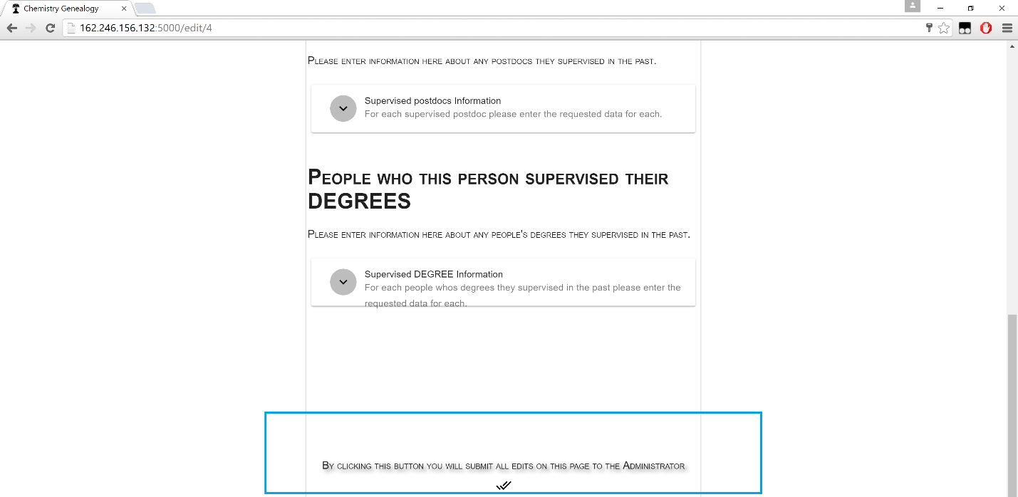

Figure 9.5: Final Submission Button on the Edit Page.

Once the user hits this button, the edit page’s information will be collected and delivered to the application database and make permanent changes to the application data.

# 10. Admin Panel

The Admin Panel is the part of the application that **only administrators** have access to. This is where the decision to accept or reject a submission, accept or reject a new registration and other administrator tasks can be fulfilled.

# 10.1. navigating to the admin panel

This is assuming that the user has already reviewed how to log in and possesses an administrator account. If you do not know how, please review the sections earlier within this User Manual.

To navigate to the admin panel, when logged in with an administrator account, please click the button depicted below in figure 10.1.



Figure 10.1: Admin Panel Button to navigate to the Admin Panel from the header.

Now the administrator should be on the Administrator Panel as depicted below in figure 10.2.

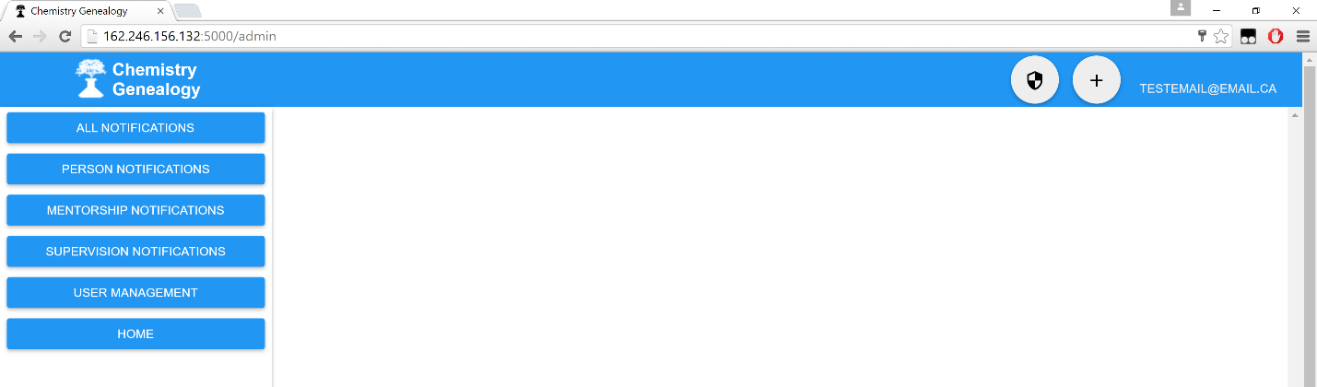

Figure 10.2: Admin Panel.  
Currently there are no notifications within the Admin Panel depicted here.

# 10.2. notifications

This application has a constant stream of data coming into it. Meaning that the administrator will have a constant stream of data that he/she must approve. In order to do this the admin panel has a notification system built into it.

This is immediately present on the Admin Panel upon navigation to it.  
Note: The earlier figure (10.2) was of an empty Admin Panel.

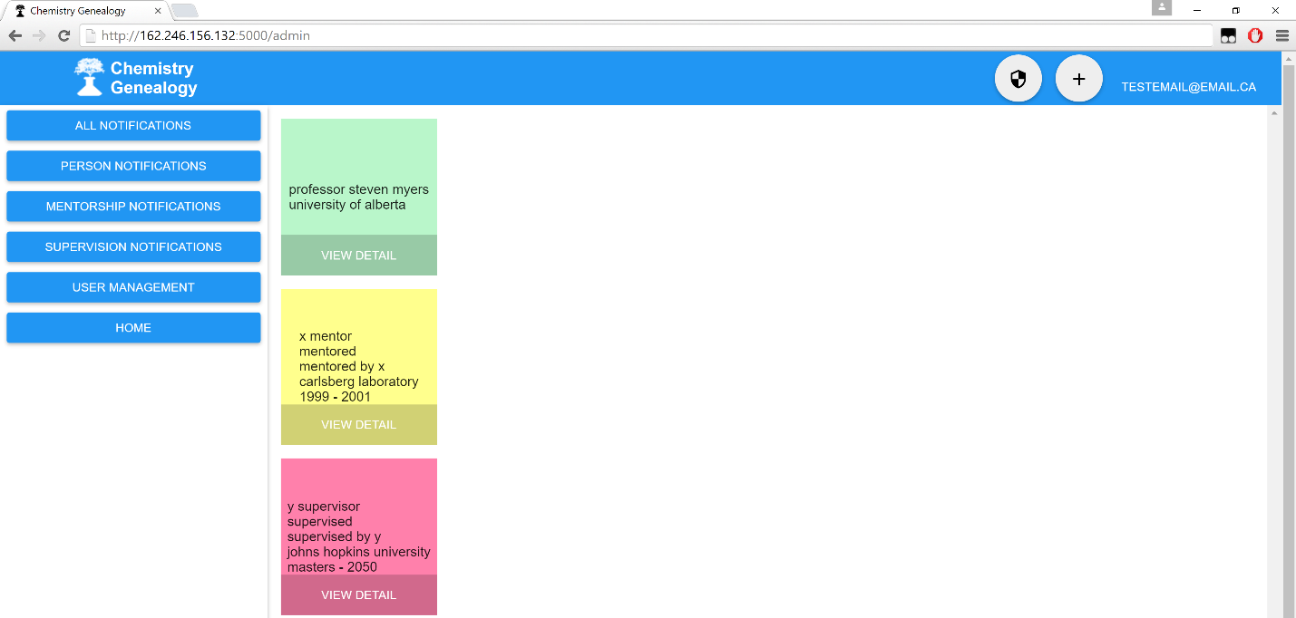

Figure 10.3: Admin Panel with notifications.  
There are currently 3 notifications, one of each type.

On this page you can notice that there are 3 different columns, this represents the 3 different types of notifications

1. Green represents person notifications.

2. Yellow represents mentorship notifications.

3. Red represents supervision notifications.

The buttons located on the left side of the administrator panel contain filters to view only a particular type of notification, assisting the Administrator in reducing clutter or being overwhelmed with too many notifications.

# 10.3. approving registered users

Anyone can navigate to this webpage and then register for this website. In order to control the influx of new registered users of this application the administrator has the power to either accept or reject new potential users of the system.

To get here, navigate to the Administrator Panel.

On the left side of the Administrator Panel you will see a button that says User Management, click it.

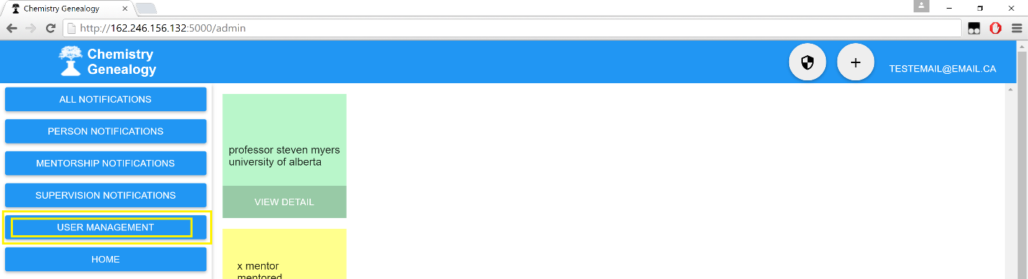

Figure 10.4: Admin Panel User Management Button.  
Click here to navigate to manage the newly registered users of this system.

Now on this page you have two options for each user, to either accept or reject their registration. In order to do either of those functions merely click the associated button.

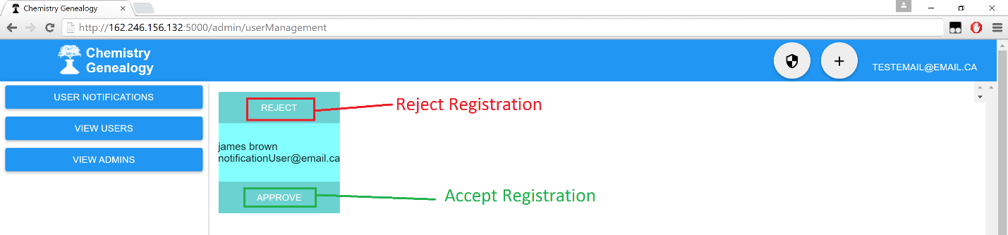

Figure 10.5: Admin Panel User Management Page.  
Either accept or reject registration of that user.

# 10.4. Viewing current administrator group

From the Administrator Panel please click the User Management Button.



Figure 10.6: Admin Panel.  
Note the User Management Button highlighted in Yellow.

Now on the User Management page click View Admins

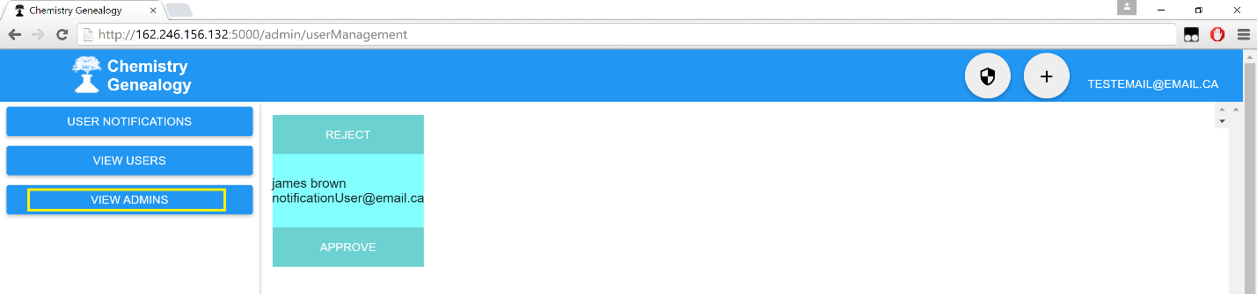

Figure 10.5: Admin Panel User Management Page.  
Note the View Admins Button Highlighted in Yellow.

Now you will arrive to the page that lists all of the current administrators of this application, along with their associated email.

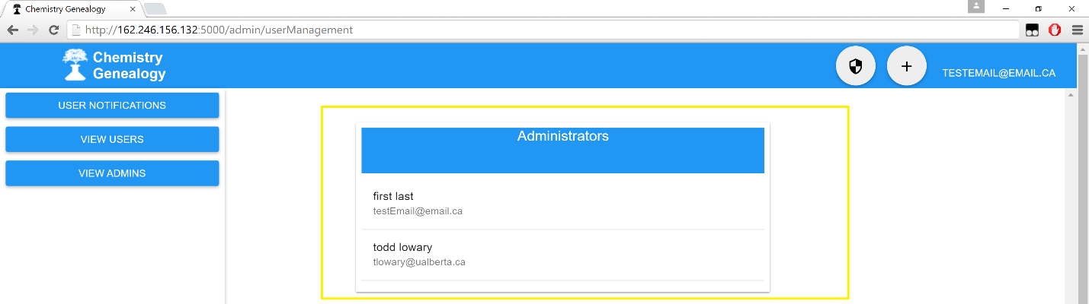

Figure 10.6: Admin Panel Current Administrator List Page.  
Note the List of Administrators Highlighted in Yellow.

# 10.5. Viewing current user group

From the Administrator Panel please click the User Management Button.



Figure 10.7: Admin Panel.  
Note the User Management Button highlighted in Yellow.

Now from this page hit the View Users Button.

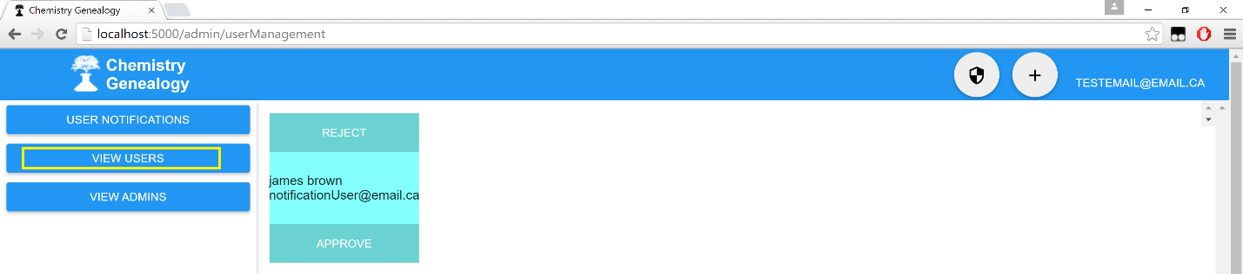

Figure 10.8: Admin Panel User Management Page.  
Note the View Users Button Highlighted in Yellow.

Now you will be on the page where you can (1) view the list of users (2) promote their status to Administrator of the system (3) revoke their account access to your application. Merely press the buttons you desire to have happen.

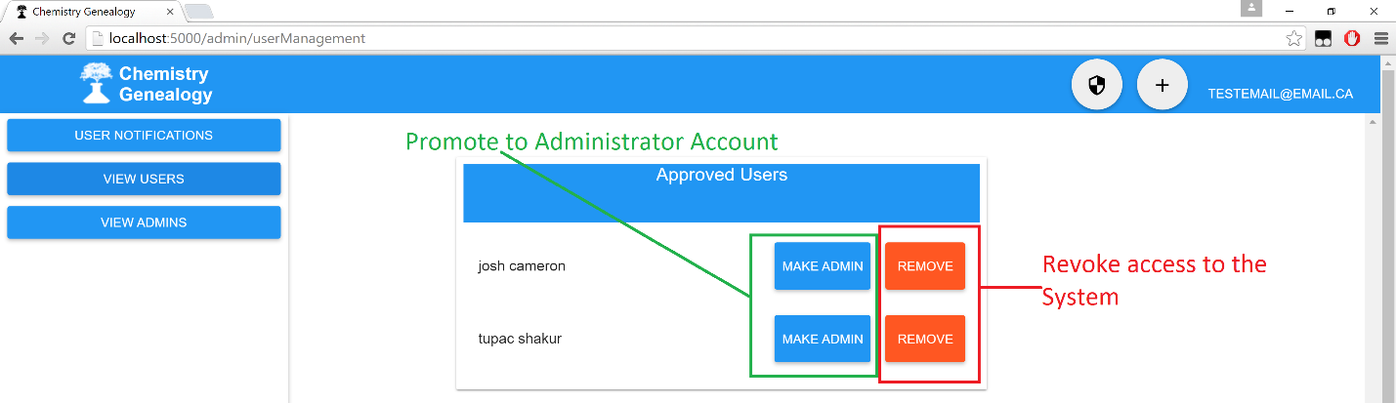

Figure 10.9: Admin Panel User Management Page.  
Note: The ability to promote, or remove user accounts from the system!

# 10.6. accepting newly submitted data

Newly submitted data into the system must **first be approved by the administrator before they are viewable by others!** Meaning that the administrator gets the ultimate say if the submitted data will or will not be within the System.

First navigate to the Administrator Panel. Now note the green, yellow and red notifications. These are changes to the data that must first be approved or they will not be allowed into the system.

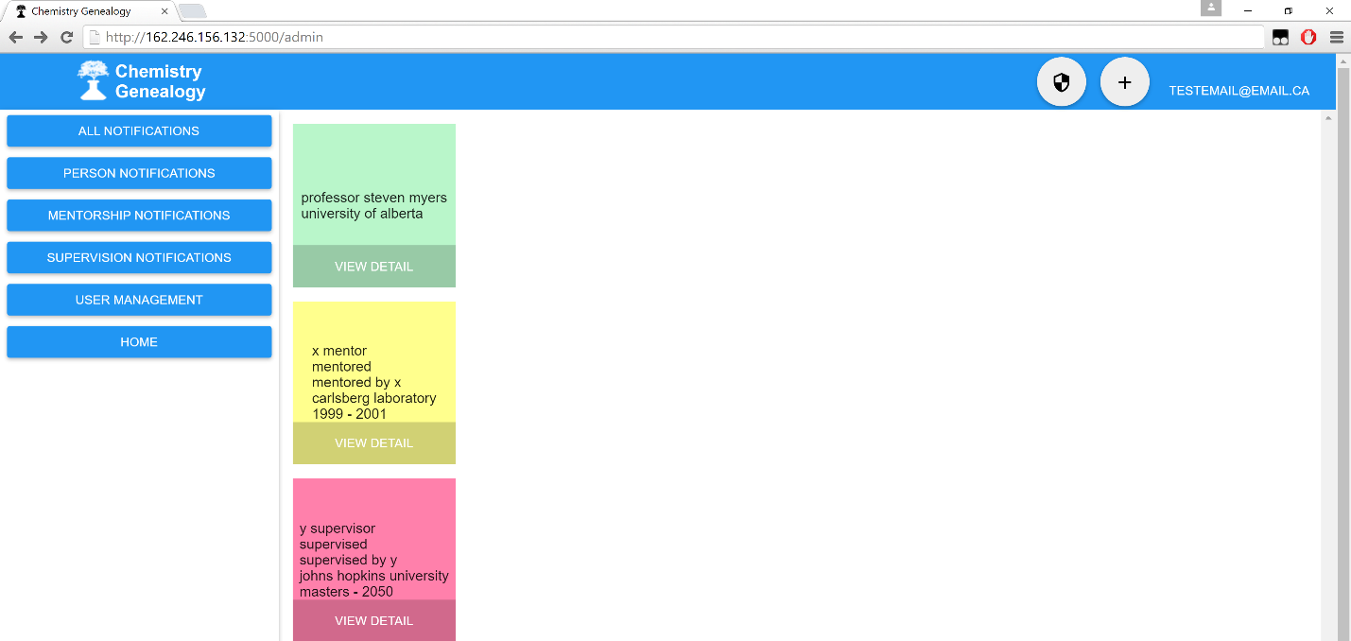

Figure 10.10: Admin Panel Notifications Page

From this page it is up to the Administrator to decide which notification in particular he/she is interested in accepting or rejecting. In order to do this, first click the View Detail Button depicted below.

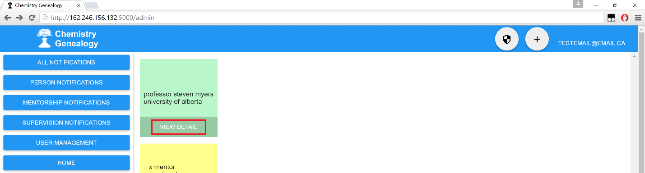

Figure 10.11: Admin Panel Notifications Page  
Note the View Detail Button highlighted in red.

From here you are now presented with a page that is extremely similar to the View Detail page, but with one major difference. You now have accept and reject buttons available to you in the top left hand corner as shown below in figure 10.12!

Note: If this page doesn’t make sense, please review the View Detailed Information section provided earlier in this User Manual! It is the exact same but with the accept/reject buttons!

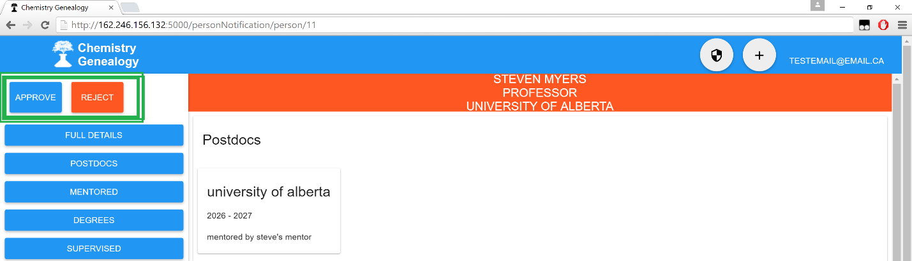

Figure 10.12: Admin Panel Notification Accept/Reject Page   
Note the Approve and Reject Buttons highlighted in Green!

For this notification, hitting either approve or reject will either approve or reject the current notification that the Administrator is on. Upon approval or rejection of the notification, the Administrator will be sent back to their main panel screen (as shown below in figure 10.13) with the approved or rejected notification gone. The changes will have been issued to the system.

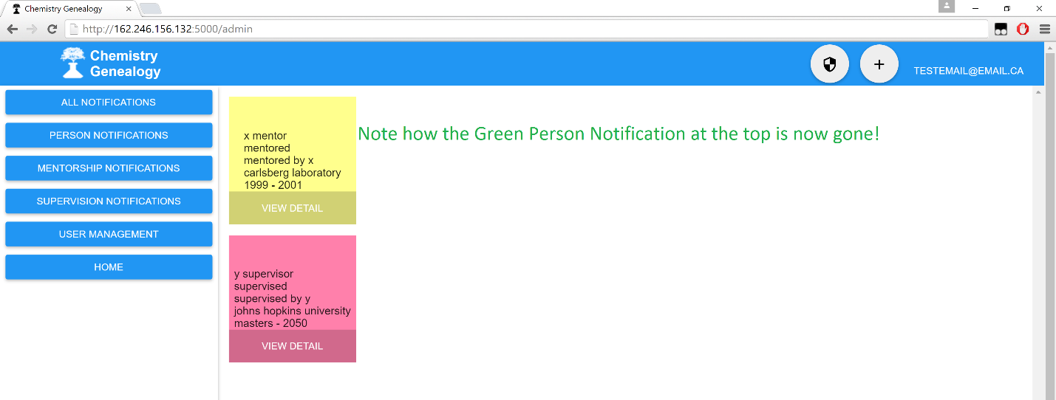

Figure 10.13: Admin Panel Notification Page  
Note the Green Person Notification at the top is now gone! It was approved or rejected!

# 11. vocabulary

Throughout this application we make use of a few special terms, I felt the need to take the time to mention how these terms are being used in the application for clarity’s sake.

1. Target:

This term is used in the application to refer to the person being searched by a user in the search bar.

Eg: Searching for John Doe makes John Doe the application target.

2. Supervised:

This term is used in the application to refer to individual’s who the current user being viewed has supervised the degree of in the past.

3. Supervisor:

This term is used in the application to refer to the person who supervised the currently viewed individual during their degree.

4. Mentors:

This term is used in the application to refer to the person(s) who have mentored the currently viewed individual during a postdoctoral appointment.

5. Mentored:

This term is used in the application to refer to the person(s) who have been mentored during their postdoctoral appointments by the person currently being viewed.